**PORTOFOLIO**

Logo

 

 

 

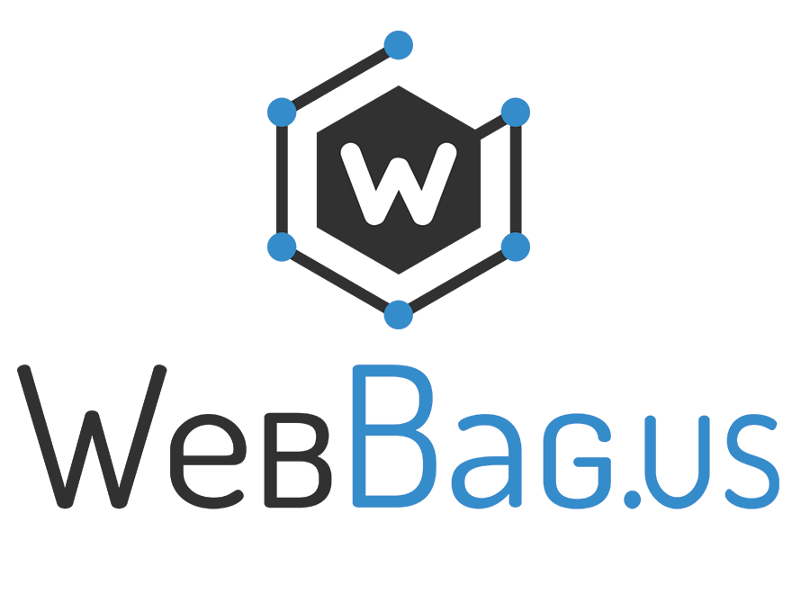 

 

Website

**Kesra & PPID Kota Batu,** 2012

Goverment site; build with Lokomedia CMS.

Web Technologies: PHP, MySQL, HTML, CSS, Bootstrap, JavaScript, jQuery

**Squirel (Sumber Belajar SQL Terlengkap) – Project Skripsi,** 2013-2014

All in one educational resource; contain modul, quiz, report, and offline SQL compiler

Web Technologies: PHP, MySQL, HTML5, CSS3, Bootsrap, JavaScript, jQuery, CodeIgniter

**Webbag.us,** 2014

Just templating my personal blog

Web Technologies: PHP, MySQL, HTML5, CSS3, jQuery, Wordpress

**Trigger – CMS by Kapanlagi,** 2015

Build frontend based on database and backend.

Web Technologies: PHP, MySQL, HTML5, CSS3, jQuery, CodeIgniter

**KLN Guestbook,** 2015

Just simple guest book for KLN web visitor.

Web Technologies: PHP, MySQL, HTML5, CSS3, Bootstrap, CodeIgniter

**Saku – News grabber,** 2015

Build system to grab news from determined website and provide API for Android.

Web Technologies: PHP, MySQL, HTML, CSS, Smarty, Xpath

**7Shop – Multi seller online shop,** 2015

Multi seller online shop, build on opencart with multimerch plugin.

Web Technologies: PHP, MySQL, HTML5, CSS3, JavaScript, Bootstrap, Opencart

**API for Mattreal mobile apps,** 2015

Provide API for mattreal mobile apps.

Web Technologies: PHP, MySQL, HTML, CSS, JavaScript, jQuery

**Royal Unity Booking Engine,** 2015-2016

Wep application for booking hotel.

Web Technologies: PHP, MySQL, HTML, CSS, JavaScript, jQuery

**RFbespoke – Online shirt designer,** 2016

Online shirt designer, users are able design shirt as they want. Build with codeigniter and HTML5 canvas for image manipulation.

Web Technologies: PHP, HTML5, CSS3, JavaScript, jQuery, Canvas, CodeIgniter

**Field-IQ – PT. HM. Sampoerna CRM (Customer Relation Management),** 2016 - 2017

Wep application for salesman (to manage customers and sales) and for supervisor (to track and manage salesman)

Web Technologies: PHP, MySQL, HTML, CSS, JavaScript, jQuery

Helps companies stay connected to customers, streamline processes, and improve profitability.

Web Technologies: HTML5, CSS3, JavaScript, jQuery, Asp.Net, C#, Gmap API, Ms. SQL Server, Entity Framework

**Kesra Kota Batu**

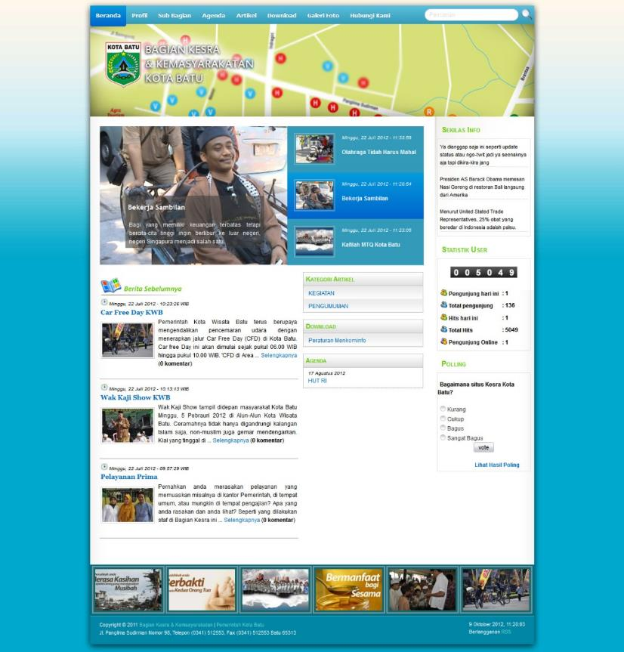

**PPID Kota Batu**

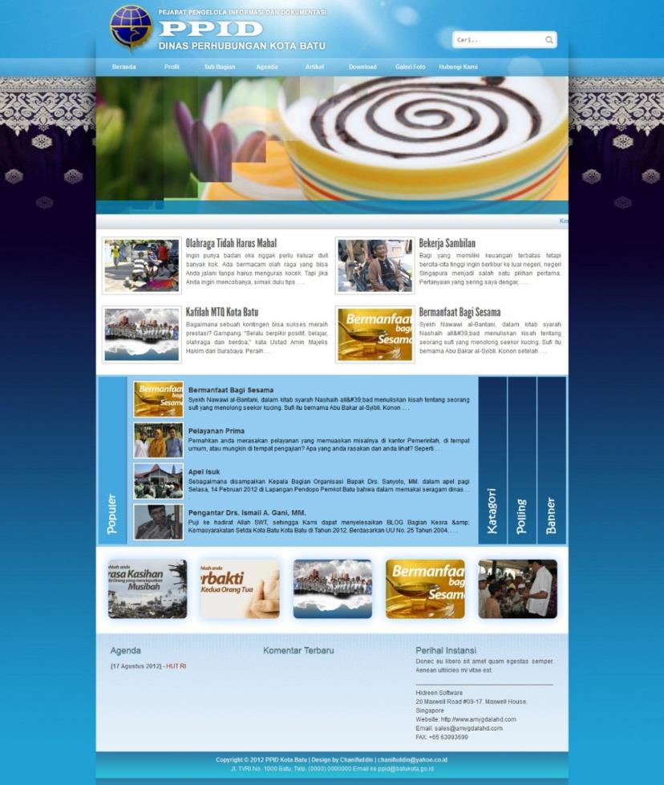

**Squirel – Project Skripsi**

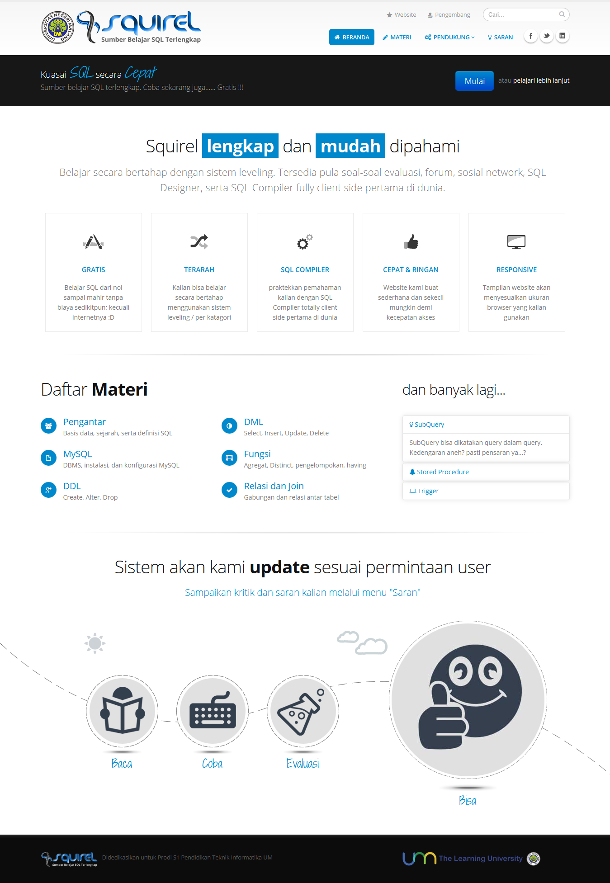

**Webbag.us – Personal Blog**

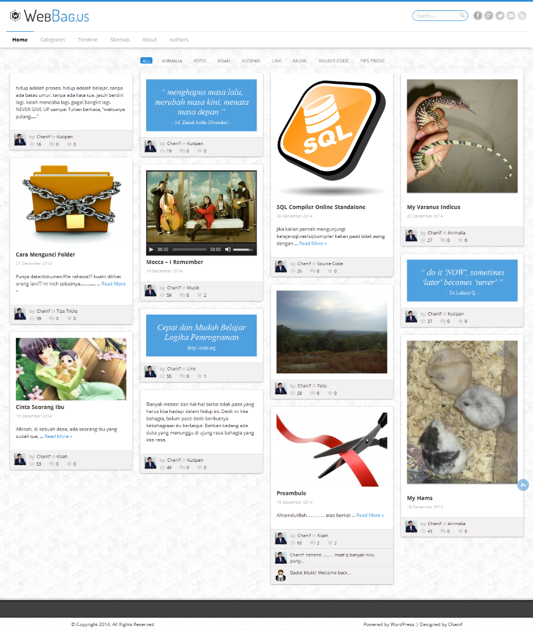

**Trigger (KLN CMS)**

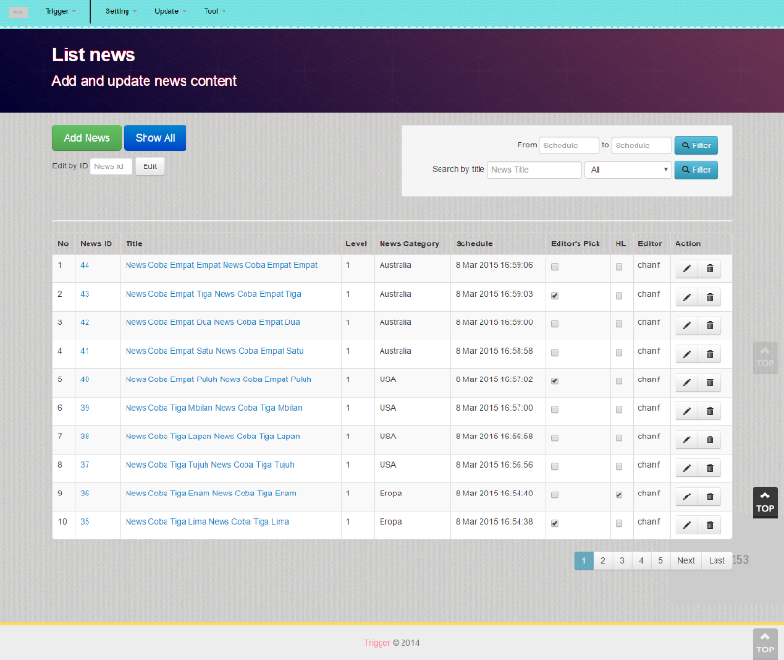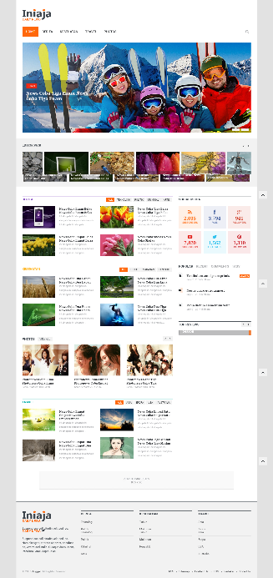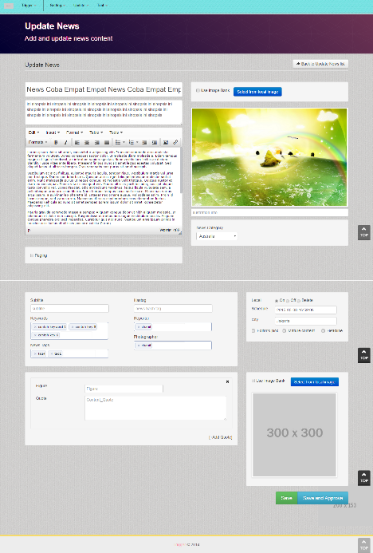

**KLN Guestbook**

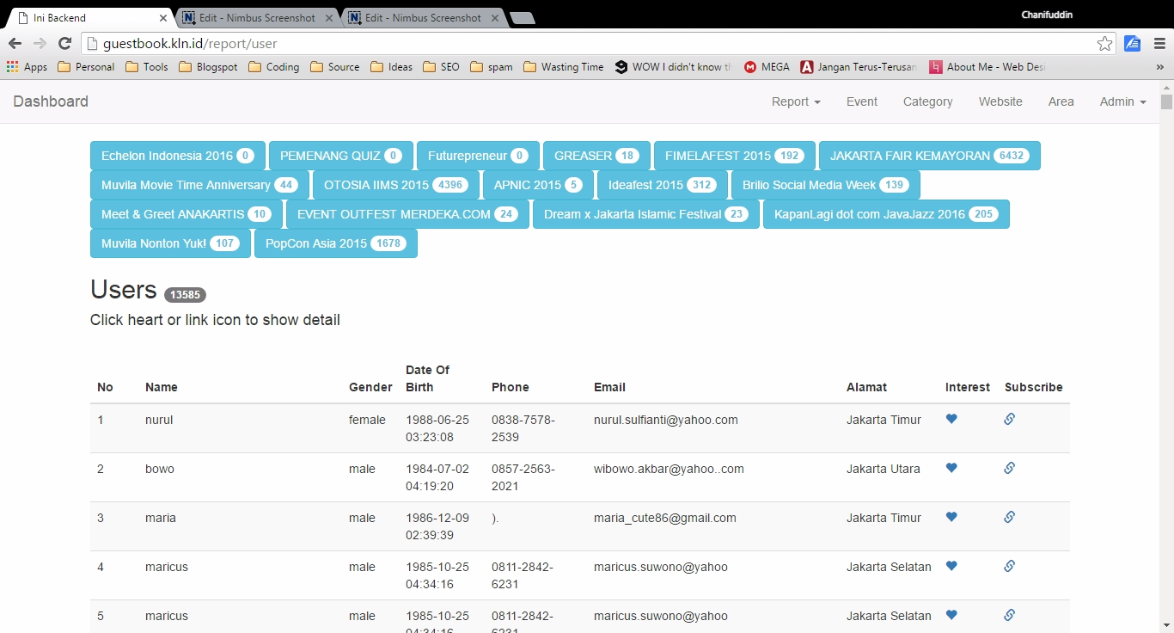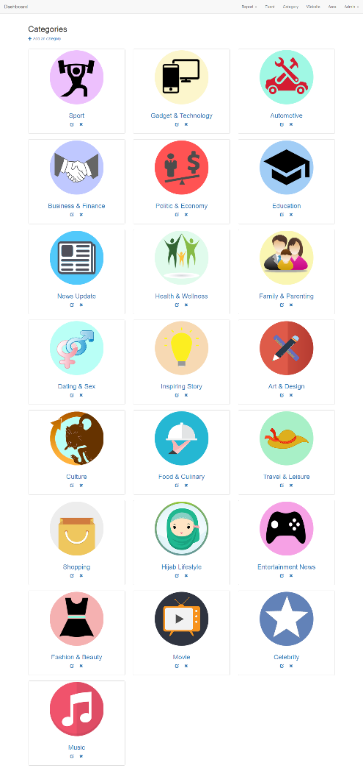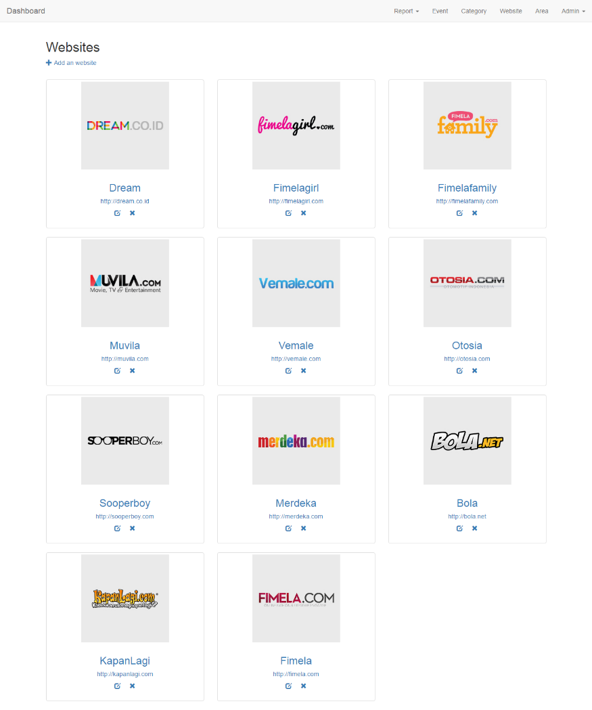

**Saku (News Reader App)**

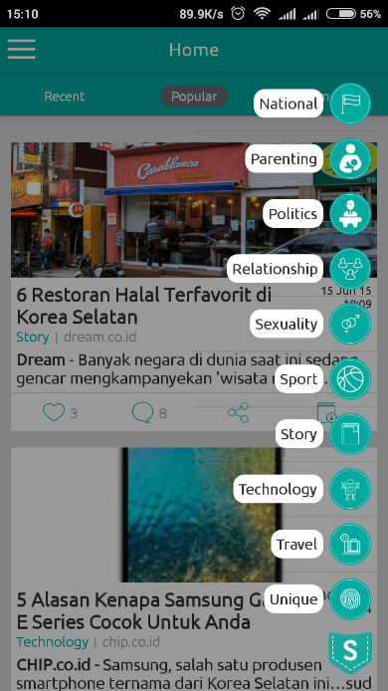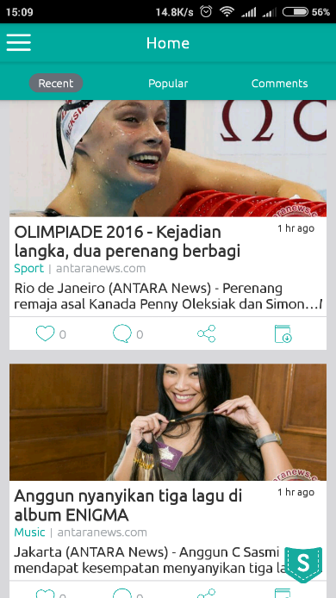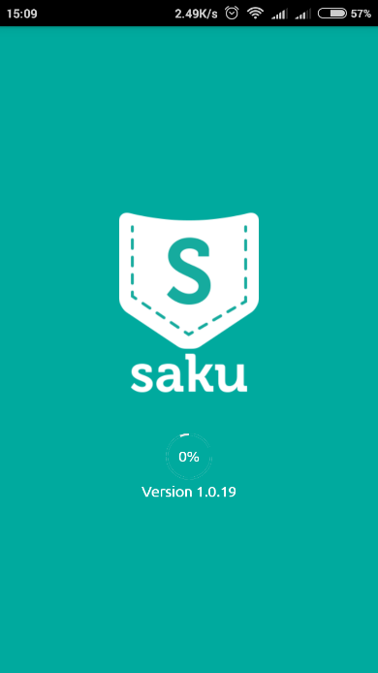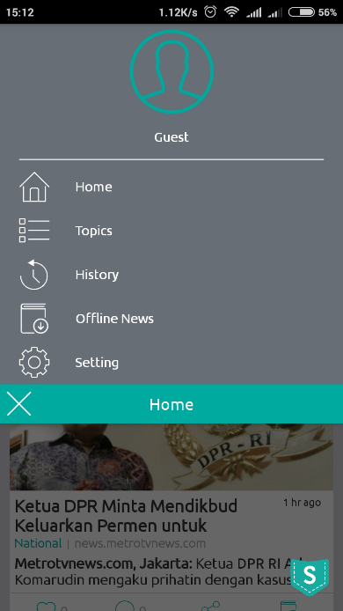 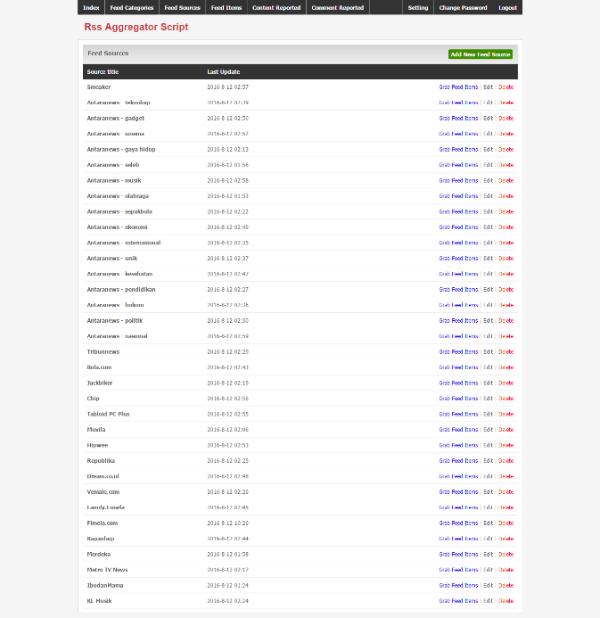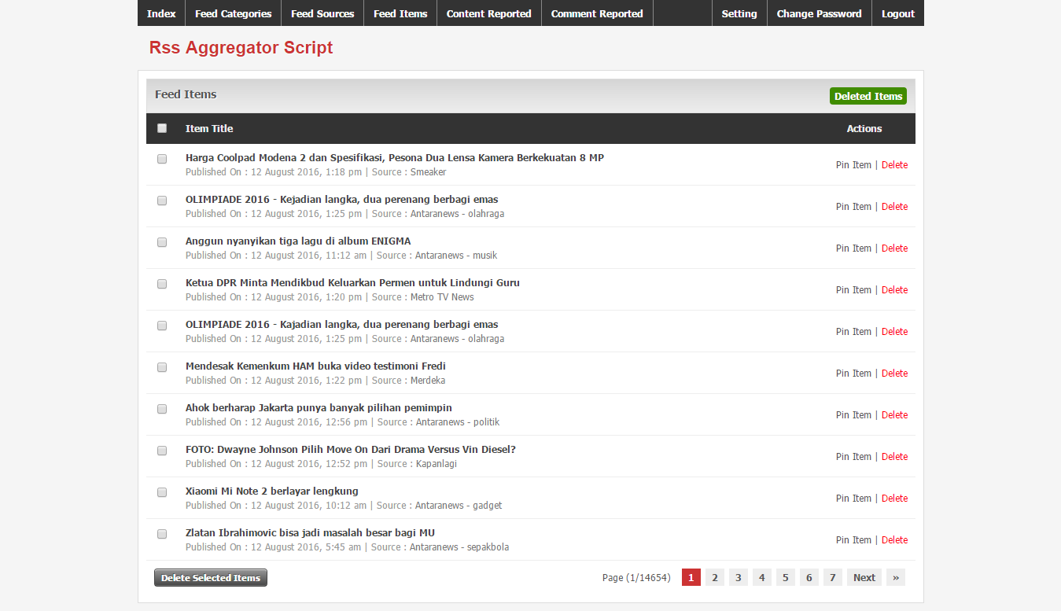

**7Shop (E-commerece)**

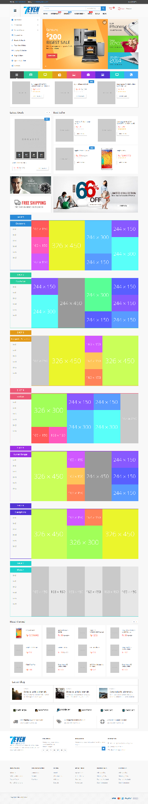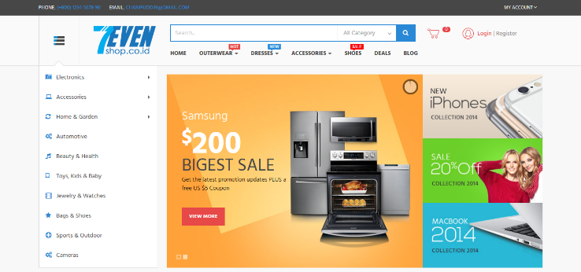

**API for Mattreal (Android App)**

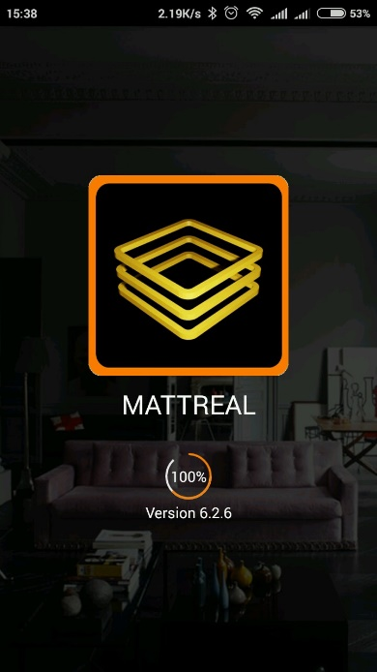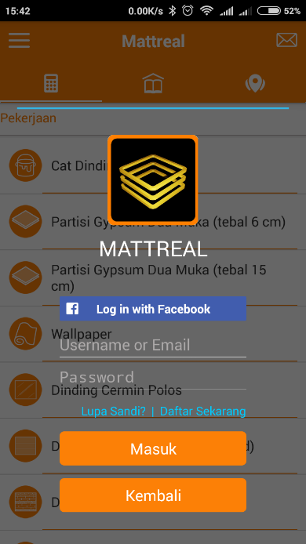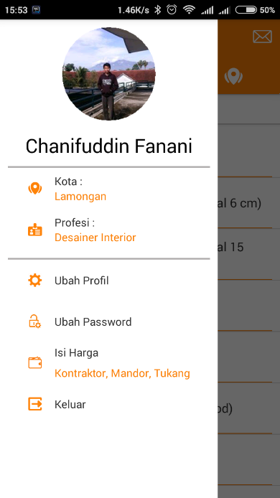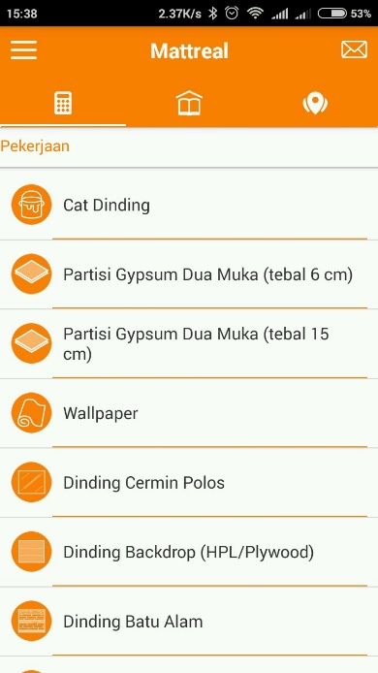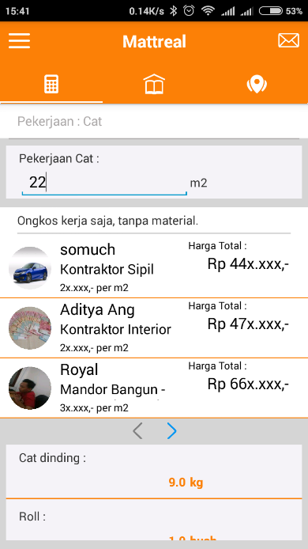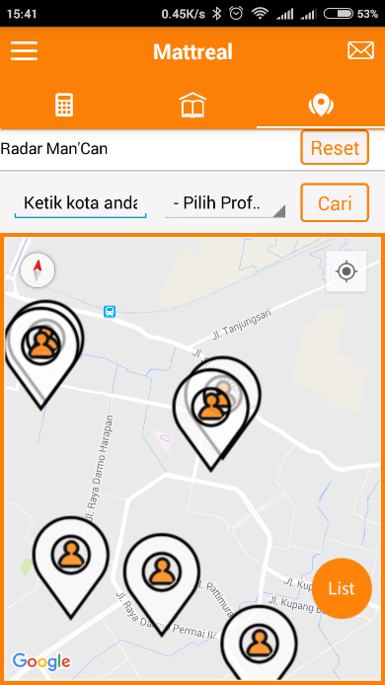

**Royal Unity Booking Engine (Hotel Booking System)**

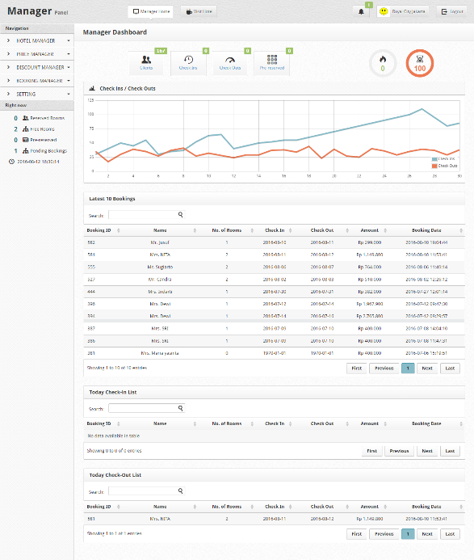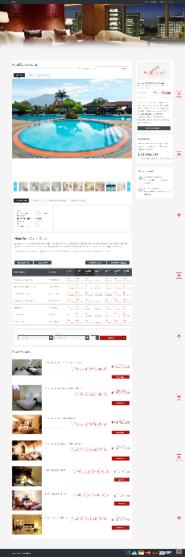

**RFbespoke (Online Shirt Designer)**

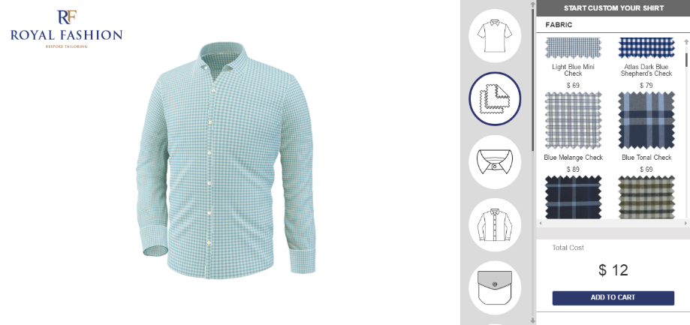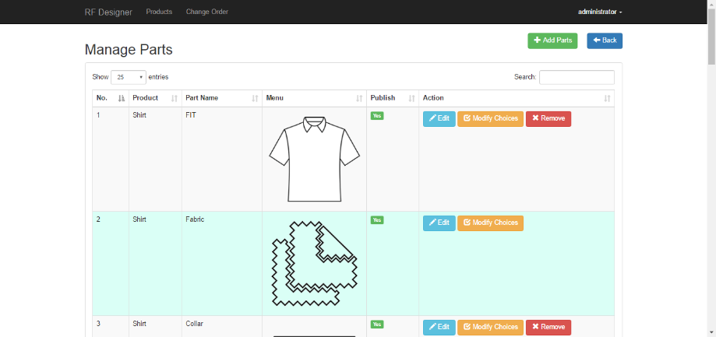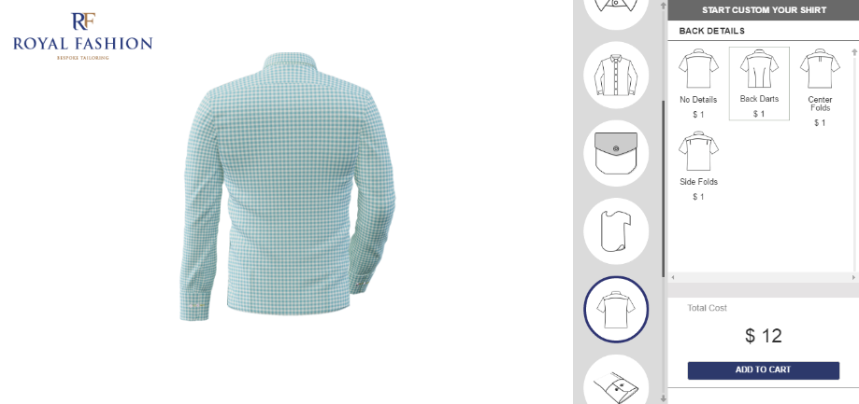

**Field-IQ – PT. HM. Sampoerna CRM (Customer Relation Management)**

